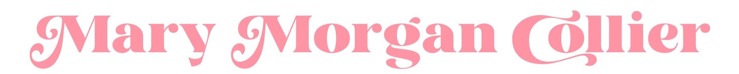

─────────────────────────────────────────────────────
  jdrfmmc@gmail.com |   (706) 612-5555 |   201 S Wilkinson Street
─────────────────────────────────────────────────────
E D U C A T I O N  JEFFERSON HIGH SCHOOL  Graduated 2020  GPA: 4.0  GEORGIA COLLEGE &  STATE UNIVERSITY  Junior  Theatre & English Double Major  H O N O R S  Excellence in Fundraising  2011-2016  Juvenile Diabetes Research Foundation  Best Human Rights Film  2020  (Giving Voice)  Cannes World Film Festival  Best Actress of the Season  2022  (Puffs)  Alpha Psi Omega  Freshman of the Year  2021  Alpha Psi Omega  Irene Ryan Performance Nominee  2022  (Medea)  Kennedy Center American  College Theater Festival  M E M B E R S H I P S  ARF & Friends  Gamma Sigma Sigma  GC Leadership Program  The Honors College  The Give Center  The Alpha Lambda  Delta Honor Society | P R O F I L E  Hello! I am Mary Morgan Collier, a junior at Georgia College & State University. I am dedicated to achieving a well-rounded education on and offstage - I spend my time studying, rehearsing, and participating in organizations that align with my academic and artistic goals. However, you can also often find me ordering iced coffees, thrifting, or watching David Lynch movies. I am highly motivated to succeed, and I hope my passion translates to creative results in all of my ventures.  ────────────────────────────────────  E X P E R I E N C E  L E A D E R S H I P  - State Thespian Officer of Georgia Thespians: 2019-2020  - Aided in the supervision of over 7,000 student thespians  - Fundraised thousands of dollars for students to attend the conference  - GCSU Leadership Academy student: 2021-Present  - Taken 2 leadership courses  - Candidate for GCSU’s leadership practicum  - Social Chair of Alpha Psi Omega: 2021-2022  - Organized, advertised, and led 8+ socials  - President of Alpha Psi Omega: 2022-present  - Presides over board and cast meetings  - Aids in creative problem solving for the organization  - TEDxGeorgiaCollege  - Curates and arranges official independent TEDx events  - Sparks new conversations about the power of the public square  T H E A T R E  - Governor Honors Program Student: 2018  - Theatre Major  - Communicative Arts Minor  - Director and adaptor of “Recitatif”: 2021  - Georgia College Honors Project  - Staged Toni Morrison’s short story  - Production Manager of MisCast: 2022  - Oversaw 40+ actors and crew member for the musical revue  W O R K E X P E R I E N C E  - Academic Coach: 2022  - GCSU’s Bridge Scholar Program  - Provided supplemental instruction to students in  rigorous summer collegiate courses  - Leadership Facilitator: 2022-2023  - GCSU’s Leadership Program  - Guides students in the Leadership Academy via  consultation and designing original content

